Mississippi Entomological Association,
and Mississippi Association of Plant Pathologists and Nematologists
Annual Conference
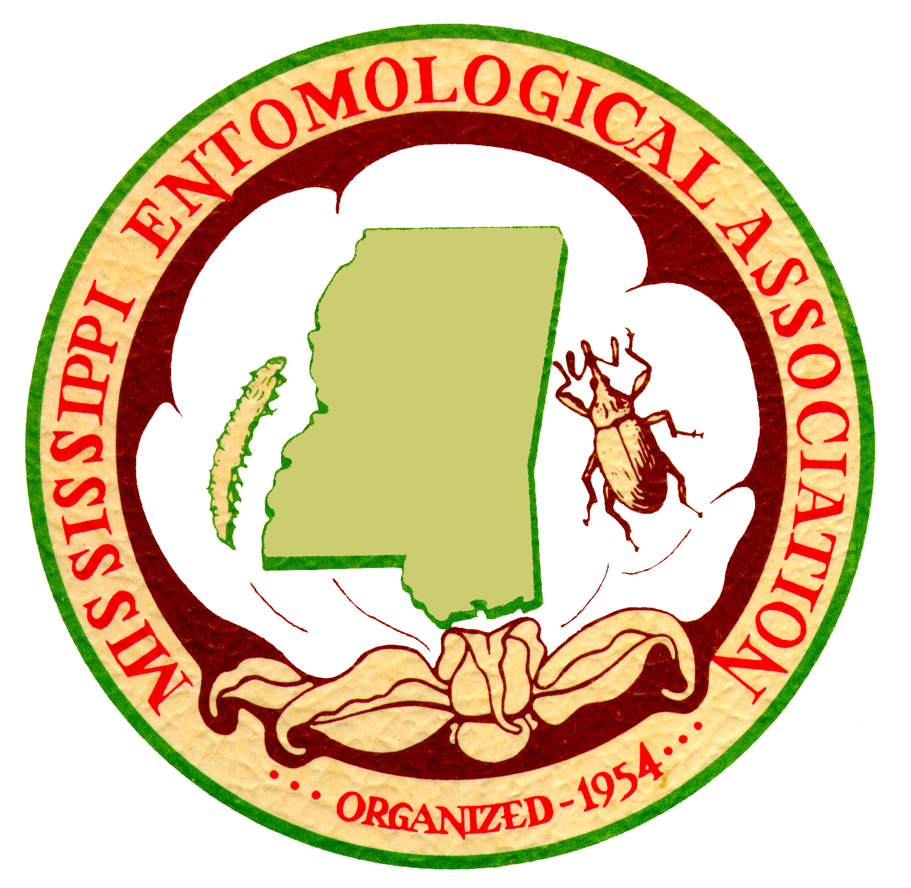

October 16-17, 2017
Bost Building, Mississippi State University

Advanced Registration Form

NAME: _____________________________________________________________

COMPANY: _____________________________________________________________

EMAIL ADDRESS: _________________________________________________________

MAILING ADDRESS: ______________________________________________________

______________________________________________________

TELEPHONE NO.: ________________________

Registration fee includes the awards luncheon on 10/17, annual membership dues and meeting registration. Saves $20 compared to on-site registration fees. | FEE |  | Amount Enclosed
CONFERENCE REGISTRATION | Member | Student
Mississippi Entomological Association | $75.00 | $40.00
MAPPAN | $75.00 | $40.00
Both | $100.00 | $50.00

Donation to 4-H entomology program
Donation to MEA Scholarship Fund
Donation to Frank Killebrew Scholarship
TOTAL | - | -
All attendees are invited to the Industry sponsored free mixer and steak dinner on Monday evening at the MAFES Conference Center? (Enter 0 if not attending) | Free | Free | No. attending  _______

